ECONOMICS
Institution
Date of submission

Macroeconomics
U.S CONSUMER PRICES PUSH HIGHER, HIGH UNEMPLOYMENT LIKELY TO KEEP LID ON INFLATION.
The consumer prices increased in the American economy while the inflation rate was fundamentally increasing despite the profits realized on goods and services. The price increase was caused by the abrupt closure of small businesses to contain the spread of the coronavirus. The high prices have posed a deflation threat. When the general price levels reduce this becomes a problem when the country is undergoing recession for the consumers and business will opt to take a long time before making purchases they will retain their cash waiting for the prices to lower. The consumer price index has been fluctuating there was a record of an increase of 0.6 percent where the gasoline company hard contributed to a quarter share in the earnings. From the statistics of the economy, the consumer price index also made the same incremental margin in June. After the countries financial end in July the preceding year the consumer price index had risen by 1.0 percent.
In computing the economic progress USA omitted volatile food and energy products which gave an increase of 0.6 percent while the motor vehicle insurance recorded a 9.3 percent increase. This was termed as the highest increase in the consumer price index. An economist considered the unemployment benefits which are offered to unemployed people this would increase due to their large numbers however the labor is important in the production, this will result in the wage pressure decrease that will restrict the growth in service sector inflation. The federal government made targets on the personal consumption expenditures which they anticipated for 2 percent inflation.
To contain inflation in the country USA central bank has taken action in amending the monetary policy, which has also led to a decrease in the interest rates. The bank has also made purchases on assets and availing loans to firms to boost their capital capability. The efforts of recovery have been limited by the coronavirus epidemic that has led to the closure of business. The country entered a recession which resulted in a great loss since the Great Depression, the recession resulted in a decrease in gross domestic product. The country adopted food price relief which led to a fall in price by 0.4 percent, the cost of food consumed at home also decreased by 1.1 percent, the prices of beef showed consistency in 8.2 percent. There was a difference in the price of food consumed away from home that showed an increase of 0.5 percent. The amount of rent paid increased by 0.2 percent this has forced the tenants to agree with their landlords on the payment issues. There was a subsequent increase in health care in July that accounted for a rise of 0.2 percent, this was caused by an increase in prices of hospital services that accounted for 0.2 percent. The price for telephone increased by 3.6 percent, cars prices increased by 2.3 percent, prices for hotel services also increased by 5.4 percent, and the airline.
The government opted to check on the inflation rate where the Federal Reserve took two actions, they decided to ensure maximum sustainable employment by ensuring there are high employment levels the economy will sustain while stabilizing the inflation rate. The reserve was to ensure there is price stability to avoid inflation. Below is the Philips curve of the American economy.
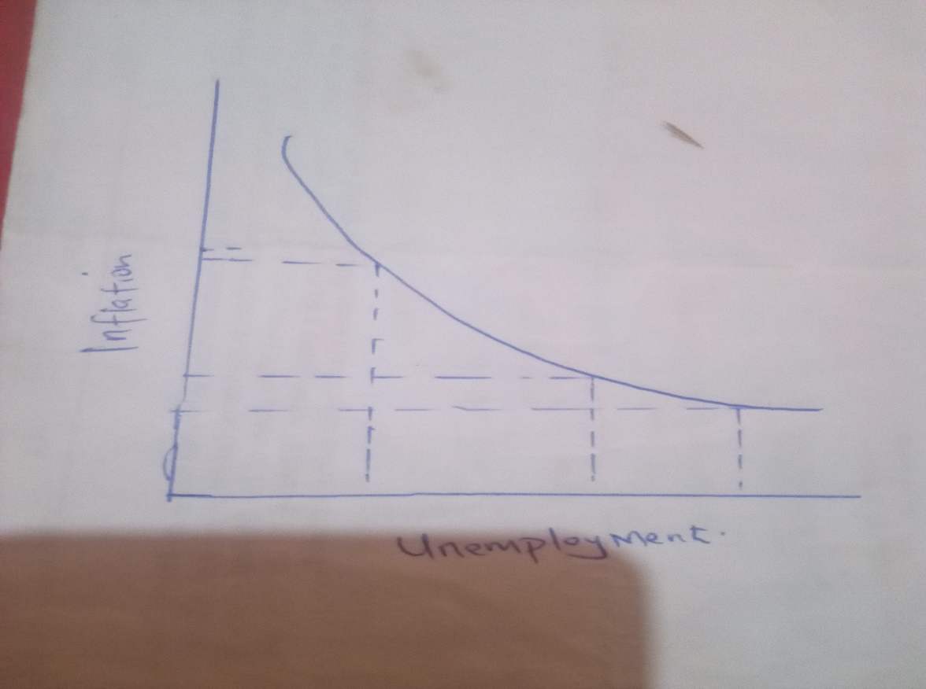

From the Philips curve the lower the unemployment rate the higher the rate of inflation, when the level of unemployment is higher the rate of inflation will also be lower.

Microeconomics
THE GOVERNMENT IMPOSES 30 PERCENT TAX ON DISTRIBUTION OF E- CIGARETTE
The government adopted taxation on e-cigarettes this was to regulate the consumption rate among the young generation due to their detrimental effects on their health at a tender age. The government decided to increase the price of the product which would pose a challenge to the young people who could not afford it due to their low purchasing power. The introduction of taxes on tobacco products is also important because it will generate income for the government. Based on the price elasticity of e-cigarettes an analysis was done showed that an increase in 10 percent price resulted in a decrease in sales volume by 8.2 percent. Based on the relevant models it indicated a 2.7 percent decrease in the short run while it also accounted for 11.7 in the long run.
An impact is assessed based on the taxation there was a 0.8 to 0.9 decrease in the rate at which young people are consuming e-cigarettes. From the analysis, it shows that tax-driven incentives will lead to a decline in consumption rate that will also affect sales made by the company because the demand will be lower than the amount supplied. The adults who consume the product are less affected by changes in the price. The adults are in a position of paying more for the product with the inclusion of other taxes. E-cigarettes has detrimental effects on people it has formaldehyde that is a danger to the health. Flavorings have a chemical known as diacetyl when inhaled it causes bronchitis. It also composes heavy metals such as copper. An analysis done by a medical practitioner showed some of the long-term effects to the young generation would lead to nicotine addiction, there would be problems in how the brain develops, this is a gateway to abuse of more complex drugs, it has also led to mental disorders, heart associated disorders.

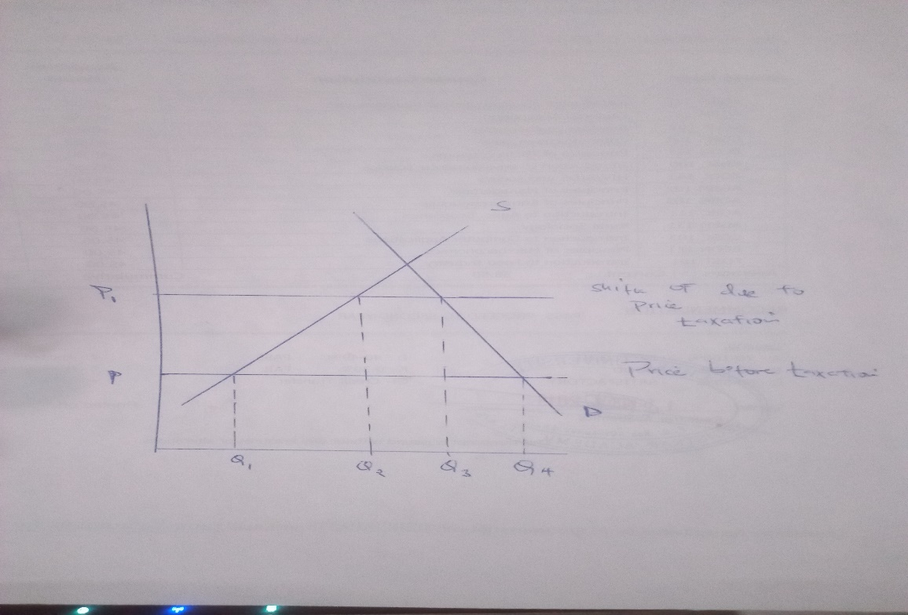
P is the price of the commodity before taxation, the amount of good demanded will be at Q4, when the tax is imposed on the e-cigarette the price will shift to p1 the amount of the good that will be demanded will decrease from Q4 to Q2 this is because some of the consumers purchasing power have been affected thus they are not in a position to demand for more. Before taxation has been introduced the quantity of E-cigarette supplied to the markets is at Q1, after taxation which will result to price changes the company will increase its supply to Q2 and Q3 in the short run. Due to taxation the demand will decrease that will result the company in decreasing the supply to match the demanded quantity. In the long run the supply will have decreased and will not attain the amount of goods compared to initial quantity before taxation has been introduced.

Reference
https://www.reuters.com/article/us-usa-economy-idUSKCN2581SA
https://foxbaltimore.com/news/local/city-leaders-want-to-impose-a-30-tax-on-the-distribution-of-e-cigarettes

